**Resources for completing SQL labs**

This course features hands-on lab activities where you’ll have the opportunity to practice using SQL queries in the terminal. You’ll use a platform called Qwiklabs to complete these labs. In this reading, you’ll learn how to use Qwiklabs.

This reading first provides a section on how to use Qwiklabs, which includes details on how to launch a lab, how to interact within the Qwiklabs environment, and how to end a lab. This is followed by another section on helpful navigation tips and keyboard shortcuts; these may be useful when working in the terminal.

**Note**: You will not launch Qwiklabs directly from this reading and instead will do this through lab activities and exemplars that you encounter throughout the course.

**How to use Qwiklabs**

**Launching Qwiklabs**

When you select a lab, you start from a Coursera page. You will need to click **Launch App** on that page. After you click **Launch App**, a new tab will open with a Qwiklabs page that contains instructions for that particular lab.

**Start Lab button**

On the Qwiklabs page, you must click **Start Lab** to open a temporary terminal. The instructions for the lab will move to the right side of the screen.

Green button with text “Start Lab” and a maximum time limit of 20 minutes displayed.

Read the instructions and complete all the tasks in the lab by entering commands in the terminal.

**Note**: It may take a moment for the terminal to start.

**Lab control dialog box**

After you click **Start Lab**, the lab control dialog box opens. It contains the **End Lab** button, the **timer**, and the **Open Linux Console** button.

You can hide or unhide the dialog box by clicking the following icon in the red box:

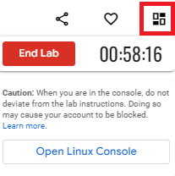

**The timer**

The **timer** starts when the terminal has loaded. The timer keeps track of the amount of time you have left to complete a lab. The timer counts down until it reaches 00:00:00. When it does, your temporary terminal and resources are deleted.

You will have ample time to complete the labs. But, stay focused on completing the tasks to ensure you use your time well.

**Open Linux Console button**

When you click the button to **Open Linux Console**, the terminal opens in a new browser window:

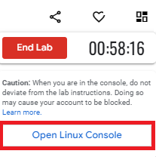

Use this feature if you want a full-screen view of the terminal. You can close this window at any time. Closing the window does not end your lab, and you can continue working in the terminal in the original tab.

**Check progress**

You can check your progress by clicking **Check my progress** at the end of each task.

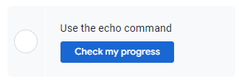

If you haven’t yet completed a task, you’ll receive hints on what you must do to complete it.

You can click **Check my progress** whenever you want to check the completion status of a task or receive a hint.

**Using copy/paste commands**

The first time you try to use copy or paste keyboard shortcuts (such as **CTRL + C**), you’ll receive a pop-up requesting permission to use your device’s clipboard:  “**googlecoursera.qwiklabs.com wants to see text and images copied to the clipboard.**” Please click **Allow** if you would like to be able to use these shortcuts in the Qwiklabs platform. If you choose not to allow Qwiklabs access to your clipboard, you cannot use keyboard shortcuts but you can still complete the lab.

**Code block**

Certain steps may include a code block. Click the copy button to copy the code provided and then paste it into the terminal.

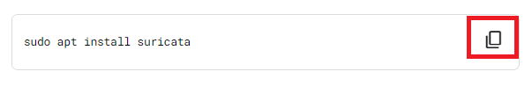

To paste code or other text content that you have copied from the instructions into the terminal, activate the terminal by clicking anywhere inside it. The terminal is active when the cursor in the terminal changes from a static empty outline to a flashing solid block.

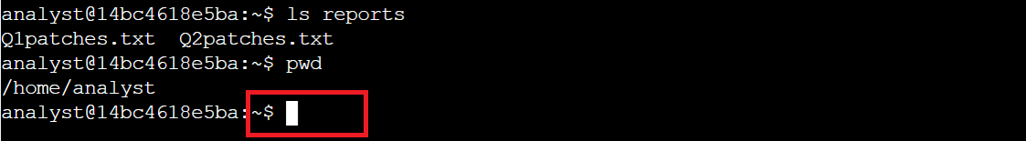

Once the terminal is active, use the keyboard shortcut **CTRL + V** (hold down the **CTRL** key and press the **V** key) to insert the copied text into the terminal at the location of the flashing cursor.

**Scrolling**

In certain situations, you may want to scroll within the terminal window. To do so, use the scroll wheel on your mouse or the touchpad of your computer.

**End Lab button**

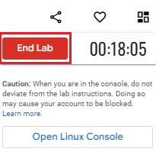

Finally, click **End Lab** when you’ve completed the tasks in the lab.

**Note**: Don't click **End Lab** until you're finished; you'll lose access to the work you've done throughout the lab.

**Tracking progress on Coursera**

If you complete a lab but your progress hasn’t been tracked on Coursera, you may need to refresh the page for your progress to be registered. Once you complete the lab and refresh the page, the green check mark should appear.

**Helpful navigation tips and keyboard shortcuts**

The following contains a list of navigation tips and keyboard shortcuts you may find useful when completing your SQL labs. Your cursor must be in the terminal window to use these navigation tips and keyboard shortcuts.

* **CTRL + C**: Terminates a command that is currently running; from the instructions portion of Qwiklabs, you can use **CTRL + C** to copy, but within the terminal, it will only terminate a command and if one isn't running, it will exit out of the MariaDB shell; if you unintentionally exit, you can reconnect by running the **sudo mysql organization** command
* **CTRL + V**: Pastes text
* **CTRL + L**: Clears the terminal screen; within MariaDB, you must use **CTRL + L** and cannot use **clear**
* **\c + Enter**: Clears the current input
* **CTRL + A**: Sets your cursor at the beginning of a command
* **CTRL + E**: Sets your cursor at the end of a command
* **Left arrow key**: Moves left within a command
* **Right arrow key**: Moves right within a command
* **Up arrow** **key**: Provides the last command you entered into the command line; can be entered multiple times to go through multiple commands from the command history
* **Down arrow key**: Provides the next command in the command history; must be after using the **up arrow** key
* **Tab** **key**: Provides available suggestions for completing your text

**Note:** If you unintentionally exit the **organization** database in the MariaDB shell, you can reconnect by running the **sudo mysql organization** command.

**Key takeaways**

Knowing how to navigate Qwiklabs will be useful as you complete the labs throughout this course. These labs can help you practice what you’ve learned in an interactive environment.